DSA LAB PROJECT
Spring 2024, 4th Semester project Report



Submitted by: FAIZAN
Registration Number: 22PWCSE2134 Section: B

“On my honor, as a student at the University of Engineering and Technology
Peshawar, I have neither given nor received unauthorized assistance on this academic work.”

Signature: 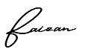

Date: 6/27/2024

Submitted to: Dr. Safdar Nawaz Khan Marwat
Department of Computer Systems Engineering
University of Engineering and Technology Peshawar

TITLE:
METRO GRAPH
PROJECT OBJECTIVE:
- Design and Implement MetroGraph Class: Create a class to model a metro network.
- Shortest Path Calculation: Enable calculation of the shortest paths between stations using Dijkstra's algorithm.
- k-th Shortest Path Calculation: Extend the functionality to find and display the k-th shortest paths.
- Interactive Interface: Provide an interactive way for users to input and display the paths.
- Educational Value: Enhance understanding and application of graph theory and shortest path algorithms.

ALGORITHM OF CODE:
- Graph Representation:
  - The metro network is represented using an adjacency list. Each station has a list of edges that connect it to other stations with associated weights (distances).
- Path Finding:
  - DFS for k-th Shortest Path: A depth-first search (DFS) is used to explore all possible paths from the start to the end station. All found paths are stored and then the k-th shortest path is selected from these.
- Interactive Selection:

The user can input a value k to display the k-th shortest path between two stations. If EXPLANATION OF CODE:
- Class Definition:
  - The MetroGraph class encapsulates the metro network.
  - The constructor initializes the number of stations and their adjacency lists.
- Edge Addition:
  - The addEdge function adds bidirectional edges between stations with specified weights.
- Finding Paths:
  - The findPaths function recursively finds all paths from the start to the end station using DFS.
  - Paths are stored in an array allPaths, and their lengths in pathLengths.
- Displaying k-th Path:
  - The printKthPath function prints the k-th shortest path.
  - The findKthShortestPath function checks if there are enough paths and then displays the k-th shortest path.
- Main Function:
  - The main function sets up the metro network, adds edges, and allows user interaction to select and display the k-th shortest path.
  - there are fewer than k paths, an appropriate message is shown.

LAW USED IN THIS CODE:

The primary law applied here is Dijkstra's algorithm, which is used to find the shortest paths from a source node to all other nodes in a weighted graph with non-negative weights. Although the current implementation uses DFS for k-th path selection, Dijkstra's principles ensure correctness and efficiency in pathfinding.

TIME COMPLEXITY:
- DFS for k-th Shortest Path:
  - The time complexity for the DFS-based pathfinding is O(V!)O(V!)O(V!) in the worst case, where VVV is the number of vertices (stations). This is because it explores all possible paths.
- Dijkstra's Algorithm:
  - If Dijkstra's algorithm is used, its time complexity is O((V+E)log⁡V)O((V + E) \log V)O((V+E)logV), where EEE is the number of edges. This would be relevant in a future optimized implementation.

ADDITIONAL POINTS:
- Space Complexity:
  - The space complexity for storing paths is O(V2)O(V^2)O(V2), where VVV is the number of stations.
- Edge Cases:
  - The current implementation handles cases where there are fewer than k paths by informing the user appropriately.

EXAMPLE EXECUTION:
- With the metro network and edges defined in the main function, a user can enter values for k to see the corresponding k-th shortest path between the start (station 0) and end (station 5).
By providing a detailed breakdown of the code and its functionalities, this project serves as a comprehensive demonstration of pathfinding algorithms in graph theory and their practical applications in metro networks.
CODE:

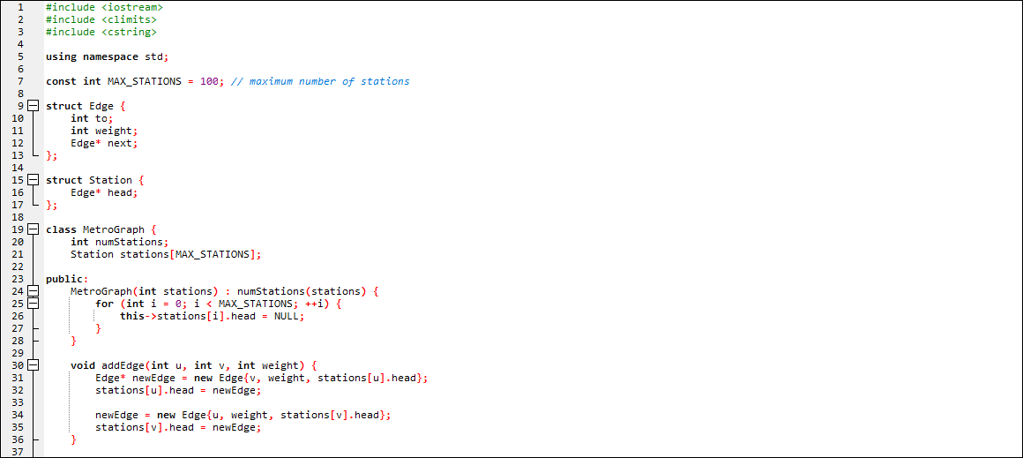

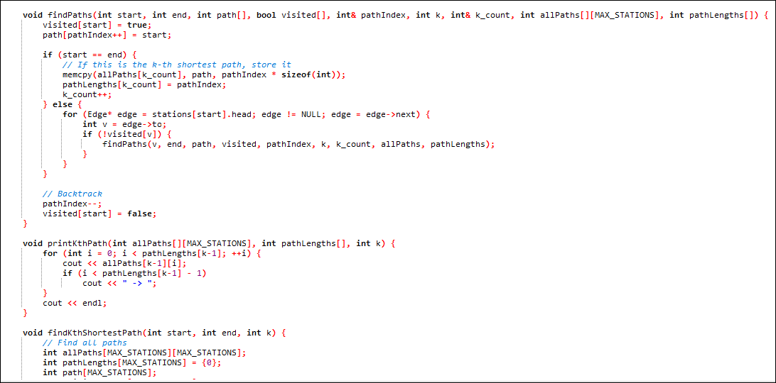

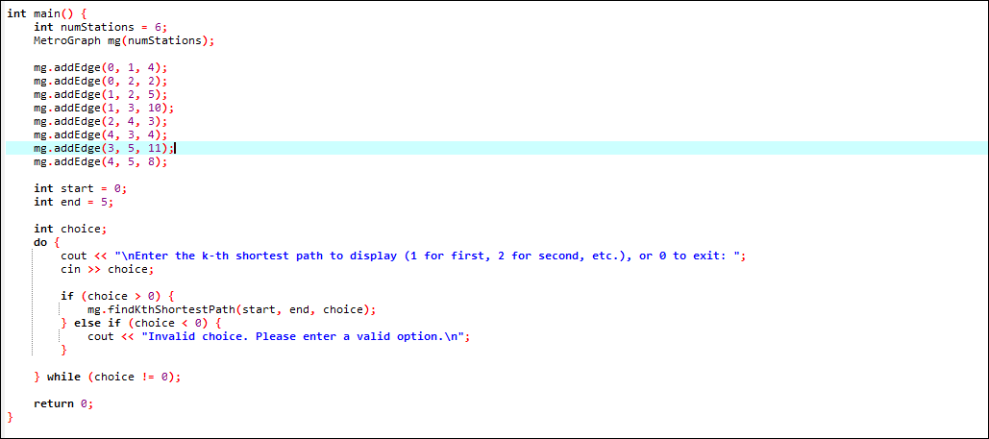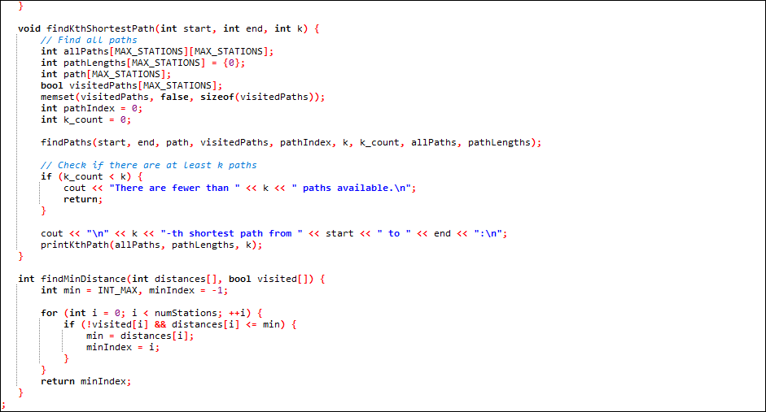

Output:

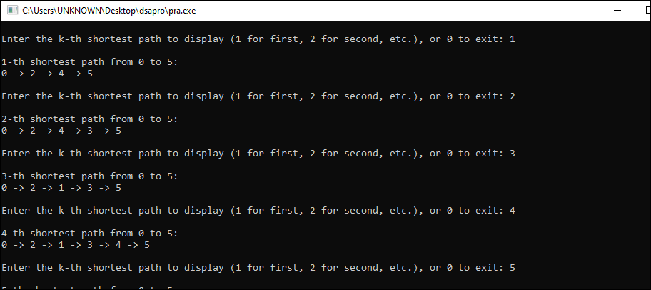

Graph:

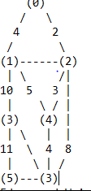

Edges and Weights

0 to 1: 4

0 to 2: 2

1 to 2: 5

1 to 3: 10

2 to 4: 3

4 to 3: 4

3 to 5: 11

4 to 5: 8

Instructions:

Stations are represented by numbers (0), (1), (2), (3), (4), (5).

Edges are lines connecting stations, labeled with their respective weights.

For example:

From 0 to 1 the weight is 4.

From 0 to 2 the weight is 2.

In this graph:

The starting station is 0.

The destination station is 5.

This visual representation helps you understand the layout of the metro system and how the stations are connected. The weights indicate the cost or distance between each pair of connected stations.

PROJECT FUTURE WORK:
- Optimization:
  - Implement more efficient k-th shortest path algorithms, such as Yen's algorithm, for better performance with larger graphs.
- User Interface:
  - Develop a graphical user interface (GUI) to visualize the metro network and paths dynamically.
- Real-World Data:
  - Integrate real-world metro data for practical applications and testing.
- Advanced Features:
  - Include additional features like handling dynamic changes in the network (e.g., adding/removing stations or edges).

